UConn COVID-19 Building Signage
Baseline
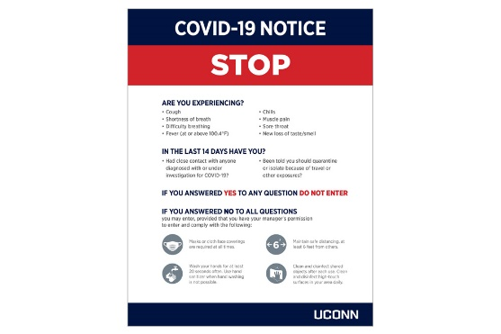 | To be posted at all building access points (State Mandate)
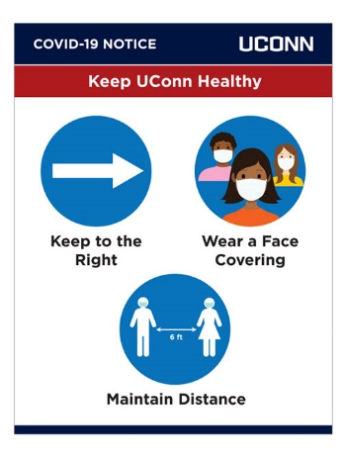 | Placed at the entrance to all stairwells on each floor and all building access points
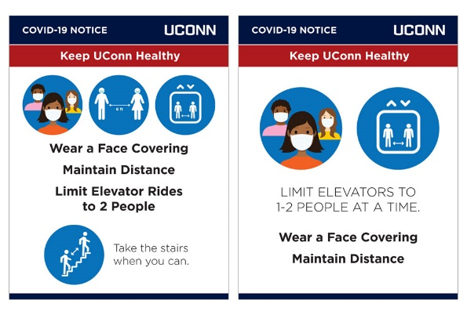 | Left: Placed outside all elevators (not on elevator door)  Right: Placed inside all elevators
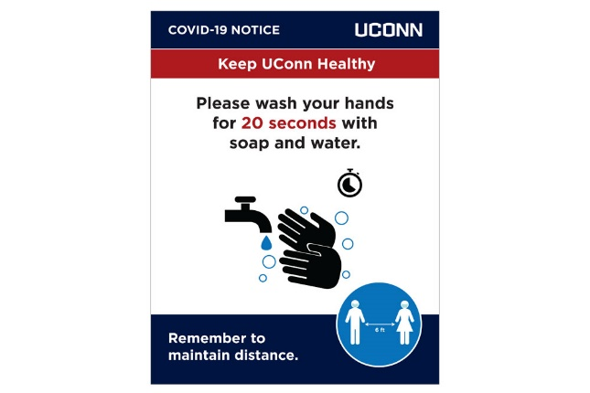 | At least 1 placed in every common-use restroom
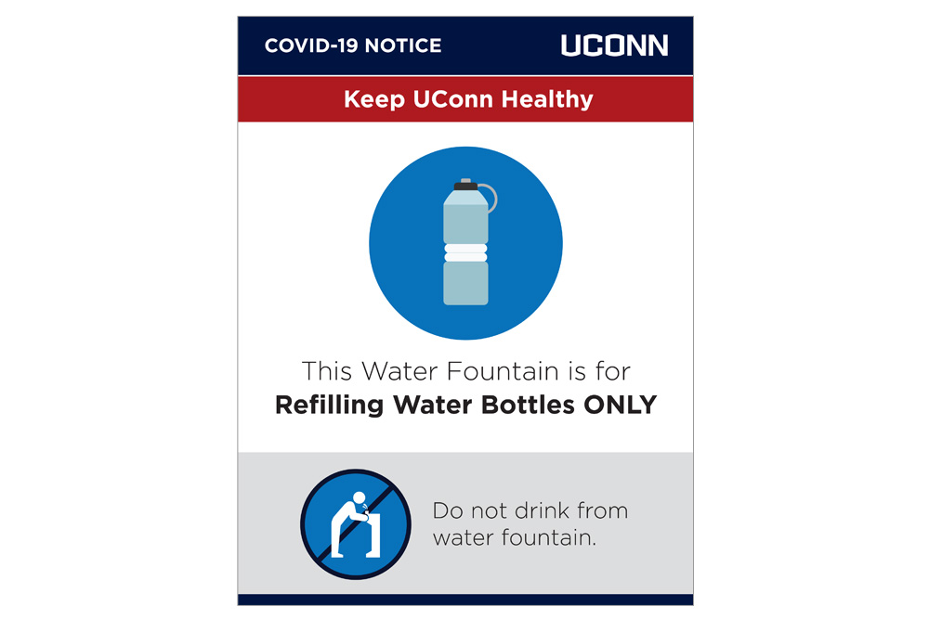 | To be placed at all water fountains
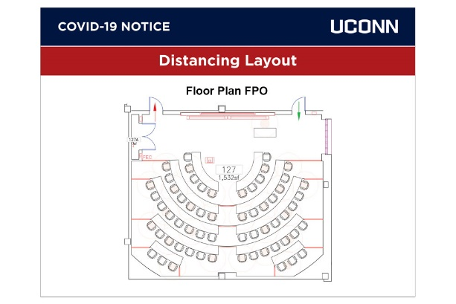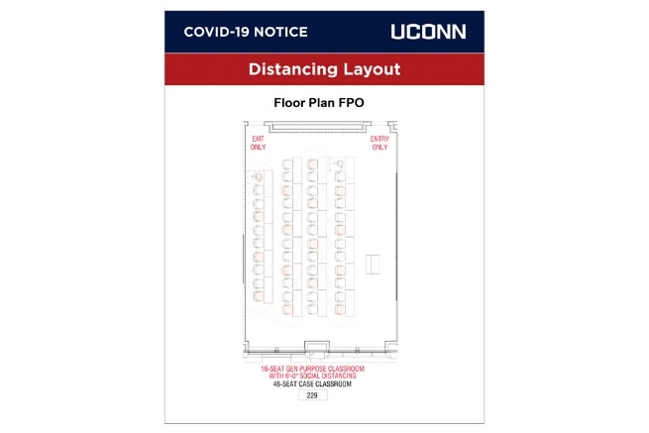 | Unique layout and updated capacity placed in sign holders in all classrooms and teaching labs.
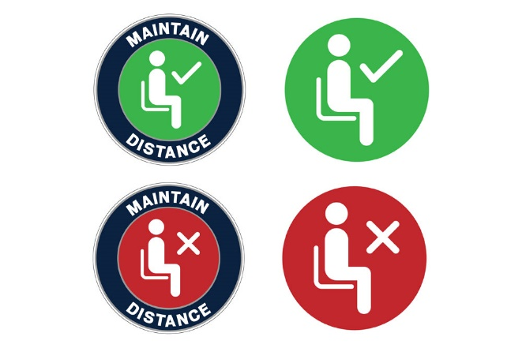 | Placed (along with layouts) in classrooms and teaching labs. For rooms with moveable seating (tablet armchairs), green stickers will be placed on the floor to match the layout diagram.

